MYSTIC TABLE BEER 12oz 6
DRAFT BEER
Saison | Chelsea, MA | 4.3% | Bright, Dry, Complex
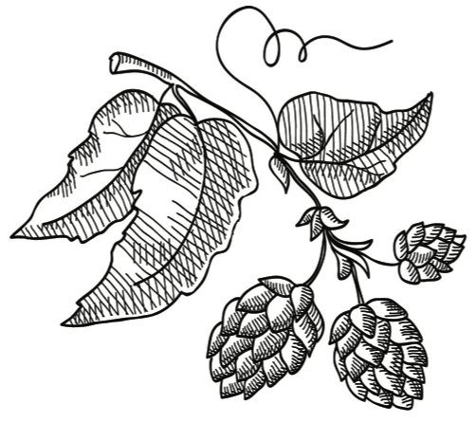
VON TRAPP PILSNER 16oz 7
Pilsner | Stowe, VT | 5.4% | Fresh, Crisp, Lemon
FIDDLEHEAD IPA 16oz 8
American IPA | Shelburne, VT | 6.2% | Resin, Citrus Rind, Melon
NOTCH INFINITE JEST 16oz 7
Hoppy Wheat Ale | Salem, MA | 4.3% | Herbaceous & Refreshing

Pucker Up, Buttercup

Drink thisNow

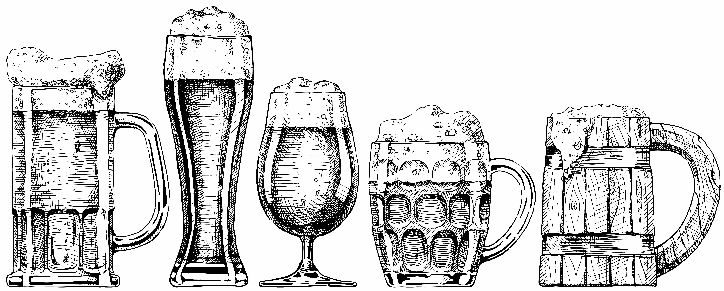
TINY HOUSE
KENT FALLS BREWING CO., CT
Hailing from Kent, CT and sourcing their own fresh hops, this collaboration between Kent Falls and Hudson Valley Brewery showcases a tart and herbaceous farmhouse beer. While zesty and herbal on the palate up front, this beer retains a funky earthiness and is hop-driven on the finish.
4% | 500ml | 16

SYLPH
DECIDUOUS BREWING CO., NH
From an emerging brewer just outside of Portsmouth, this robust farmhouse ale is an interpretation of a saison. Brett-focused and sharp on the nose, Sylph still finishes pleasant, round, and earth-driven on the palate. 7.4%| 500ml | 24
BOTTLES & CANS
Lager and Wheat Beer
ROTHAUS PILS TANNENZÄPFLE 8
Pilsner | 5.1% | Rothaus, GER | 330ml
NOTCH SESSION PILS 6
Pilsner | 4% | Salem, MA | 12oz
BUNKER BREWING CO. MACHINE PILZ 6
Czech Pilsner | 5.2% | Portland, ME | 12oz
JACK’S ABBY HOUSE LAGER 6
Golden Lager | 5.2% | Framingham, MA | 16oz
ANCHOR STEAM 6
Amber Ale | 4.9% | San Francisco, CA | 12oz
NEWBURYPORT PLUM ISLAND 6
Belgian White | 5.4% | Newburyport, MA | 12oz
AYINGER BRAU WEISSE 9
Hefeweizen | 5.1% | Aying, GER | 500ml
WEIHENSTEPHANER 9
Hefeweizen | 5.4% | Freising, GER | 500ml
ANDECHSER DUNKLES 9
Dunkleweizen | 5% | Andechs, GER | 500ml
SCHNEIDER AVENTINUS 10
Weizenbock | 8.2% | Kelheim, GER | 500ml

Patio Cider
DOWNEAST CIDER ORIGINAL BLEND 6
Unfiltered Cider | 5.0% | Boston, MA | 12oz
BANTAM ROJO 7
Dry Cherry Cider | 5.4% | Somerville, MA | 12oz
CITIZEN CIDER THE DIRTY MAYOR 8
Ginger & Lemon Cider | 5.2% | Burlington, VT | 16oz
GRAFT FARM FLOR 7
Rustic Unfiltered Cider | 6.9% | Newburgh, NY| 12oz
FAR FROM THE TREE NOVA 8
Dry-Hopped Cider | 8.0% | Salem, MA | 16oz
Malty Brews
ALESMITH NUT BROWN 8
English Brown Ale | 5.0% | San Diego, CA | 12oz
LEFT HAND MILK STOUT 7
Nitro Milk Stout | 6% | Longmont, CO | 12oz
COLLECTIVE ARTS
STRANGER THAN FICTION 8
Porter | 5.5% | Toronto, CAN | 16oz
BANDED HORN NORWEALD 6
Stout | 6.5% | Biddeford, ME | 12oz
ALLAGASH BLACK 9
Stout | 7.5% | Portland, ME| 12oz
ZYWIEC PORTER 9
Baltic Porter | 9.5% | Zywiec, POL | 500ml

India Pale Ale, et al.
HARPOON IPA 6
English IPA | 5.9% | Boston, MA | 12oz
RISING TIDE MAINE ISLAND TRAIL ALE 7
Hoppy Session Ale | 4.3% | Portland, ME | 16oz
AERONAUT HOP HOP & AWAY 9
India Session Ale | 4.6% | Somerville, MA | 16oz
JACK’S ABBY CALYPTRA 6
Session IPL | 4.9% | Framingham, MA | 12oz
BANDED HORN GREENWARDEN 8
Ale with Spruce Tips | 5.6% | Biddeford, ME | 16oz
COLLECTIVE ARTS RHYME & REASON 8
Extra Pale Ale | 5.7% | Toronto, CAN | 16oz
BANDED HORN VERIDIAN 7
American IPA | 6% | Biddeford, ME | 12oz
OTTER CREEK FREE FLOW 6
American IPA | 6% | Middlebury, VT | 12oz
BUNKER BREWING CYPHER 7
Hoppy American Lager | 6% | Portland, ME| 12oz
AERONAUT A YEAR WITH DR. NANDU 10
American IPA | 6.5% | Somerville, MA | 16oz
FOOLPROOF THE GROTTO 8
American IPA | 6.5% | Pawtucket, RI | 16oz
EXHIBIT ‘A’ THE CAT’S MEOW 10
American IPA | 6.5% | Framingham, MA | 16oz
COLLECTIVE ARTS
RANSACK THE UNIVERSE 9
Hemisphere IPA | 6.8% | Toronto, CAN | 16oz
ALESMITH IPA 8
American IPA | 7.3% | San Diego, CA | 12oz
THE TAP SOLAR PLEXUS 10
Double IPA | 9% | Haverhill, MA | 16oz

Belgian & German Style
THE TAP INTERGALATIC ACID 7
Berliner Weisse | 3% | Haverhill, MA | 16oz
EXHIBIT ‘A’ GOODY TWO SHOES 7
Kölsch Style Ale | 4.5% | Framingham, MA | 16oz
DUVEL 9
Belgian Strong Ale | 8.5% | Breendonk, BEL | 330ml
SPENCER TRAPPIST ALE 10
Belgian Pale Ale | 6.5% | Spencer, MA | 330ml
ROCHEFORT TRAPPISTES 10 12
Quadrupel | 11.3% | Rochefort, BEL | 330ml
SCHNEIDER AVENTINUS EISBOCK 14
Eisbock | 12% | Kelheim, GER | 11.2oz

BUDWEISER, BUD LIGHT....6 TECATE....5

LIMITED, RARE &
LARGE FORMAT OFFERINGS
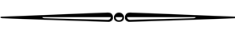

Cider, Perry, Mead
ASPALL DRY 14
English Cider | 6.8% | Suffolk, ENG | 500ml
B.NEKTAR ZOMBIE KILLER 14
Cherry Cyser | Ferndale, MI | 6.0% | 500ml
CHRISTIAN DROUIN POIRÉ 21
Perry | 4% | Coudray-Rabut, FRA | 375ml
SHACKSBURY ARLO 9
Dry Traditional Cider | 6.9% | Middlebury, VT | 12oz
ANGELÓN SIDRA DE PERA 9
Spanish Pear Cider | 5.2% | Asturias, ESP | 11.2oz
GUZMÁN RIESTRA SIDRA NATURAL 24
Spanish Cider | 6% | Asturias, ESP | 700ml
ETIENNE DUPONT BOUCHÉ BRUT 16
Farmhouse Cider | 5.5% | Victot-Portfol, FRA | 375ml
2015 ETIENNE DUPONT RESERVE 40
Barrel-Aged Cider | 6.9% | Victot-Portfol, FRA | 750ml

Sours: Tart to Face Melting
PROF. FRITZ BRIEM 1809 15
Berliner Weisse | 5.0% | Freising, GER | 500ml
CUVÉE DES JACOBINS 14
Flanders Red Ale | 5.5% | Bellegem, BEL | 330ml
PLAN BEE BARN BEER 16
Oak-Aged Wild Ale | 5.5% | Poughkeepsie, NY | 375ml
VANDERGHINSTE OUD BRUIN 9
Flanders Brown Ale | 5.5% | Bellegem, BEL | 330ml
PETRUS AGED PALE 12
Wood-Aged Pale Ale | 7.3% | Bavikhove, BEL | 330ml
TRVE BREWING CO. OSTARA 22
Tart Golden Ale | 6.9% | Denver, CO | 375ml
JOLLY PUMPKIN FUEGO DEL OTOÑO 34
Spiced Sour Ale | 6.1% | Dexter, MI | 750ml
2016 PANIL BARRIQUEÉ 38
Oak-Aged Sour Red Ale | 8% | Parma, ITA | 750ml

Farmhouse and Other Ales
KENT FALLS FARMER’S TABLE 15
Dry-Hopped Table Beer | 3.8% | Kent, CT | 500ml
BRASSERIE DE LA SENNE
TARAS BOULBA 8
Belgian Pale Ale | 4.5% | Brussels, BEL | 11.2oz
KENT FALLS EQUINOX 15
Ale with Equinox Hops | 4.8% | Kent, CT | 500ml
KENT FALLS SEMBLANCE 16
Hoppy Wheat Ale | 4.8% | Kent, CT | 16.9oz

MYSTIC SAISON RENAUD 11
Saison | 6.5% | Chelsea, MA | 375ml
SAISON DUPONT 18
Saison | 6.5% | Tourpes, BEL | 750ml
OXBOW BREWING CO. CROSSFADE 24
Blended Farmhouse Ale | 5% | Portland, ME | 500ml

Kickin’ Around the Cellar
2012 BROUWERIJ BOON GEUZE BOON 14
Geuze | 7% | Lembeek, BEL | 375ml
2010 TRAQUAIR 2020 ALE 14
English Barleywine | 10% | Peeblesshire, SCT | 11.2oz

2016 GOOSE ISLAND MADAME ROSE 38
Wild Ale with Cherries | 6.7% | Chicago, IL | 750ml

2007 3 FONTEINEN
ST. VALENTIJN CUVÉE 298
Oude Geuze | 6% | Beersel, BEL | 750ml

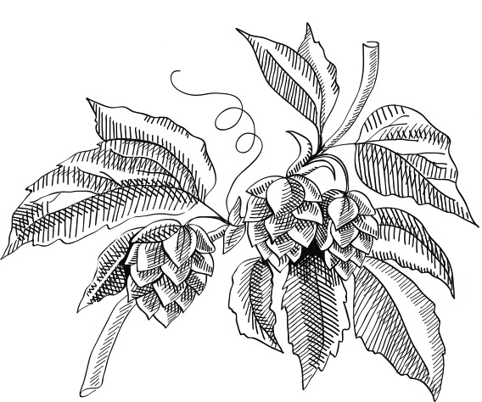

GET HUGE

Magnum

BROUWERIJ VAN STEENBERGE GULDEN DRAAK 72
Belgian Strong Ale | 10.5% | Ertvelde, BEL | 1.5L
2016 ST. BERNARDUS ABT. 12 82
Belgian Abbey Ale | 10% | Watou, BEL | 1.5L

Jeroboam

Mathusalem

BALADIN NORA 184
Ale Brewed with Spices | 6.8% | Piozzo, ITA | 3L

UNIBROUE LA FIN DU MONDE 440
Belgian-Style Triple | 9% | Quebec, CAN | 6L

